

SCHOOL *of* BUSINESS AND TECHNOLOGY

Department of Engineering and Aviation Sciences

**Project Title**

**Favour Dada**

**Jesudara Omidokun**

**Aduralere Sulaiman**

Advisor: Dr. Lei Zhang

May. 14, 2019

Project Title

By

Team member 1, team member 2, …

Submitted to the Department of Engineering and Aviation Sciences in partial fulfillment of the requirements for the degree of Bachelor of Science in Engineering at the

UNIVERSITY OF MARYLAND EASTERN SHORE

Date

The author hereby grants the University of Maryland Eastern Shore permission to reproduce and distribute publicly, paper and or electronic copies of this document in whole or in parts.

Authors Team member 1, team member 2, …

Signature

Date

Department of Engineering and Aviation Sciences

Certified by

**Special notice for formatting for the whole report:**

1. Keep the formatting consistent (learn and apply the MS ‘Styles’ in formatting). Do not change any format but just apply corresponding styles as listed.
2. Do not add any blank rows but use BREAKS, except the end of a table. BREAKS can be found on ‘Page Layout’ → ‘Page Setup’ → ‘Breaks’.
3. Every figure or picture must be mentioned in the text first then can appear. When it is mentioned, use the cross-reference.
4. Every figure or picture in the text must be accompanied with the caption and detailed description.
5. Only third person is allowed (except the Conclusion and Acknowledge sections). Never use ‘we’, ‘our’, ‘you’, etc. anywhere else (use the ‘find’ function of MS Office to double check).
6. Use ‘do not’ other than ‘don’t’, and so forth.
7. You can copy any reference information from anywhere, but anything not from yourself must be refereed and the original information must be included in the Reference section.
8. The reference must be organized with professional software such as ‘Endnote Web’, ‘Mendeley’, etc. Use IEEE reference format.
9. Try Grammarly. It can help in fixing typos and grammar errors.
10. If you get ‘Styles’ messed up, the easiest way is to start over, to open this blank template and copy-paste contents into it.

List of Contents

List of Contents 4

List of Figures 2

List of Tables 3

Abstract 4

1. Introduction 5

1.1 Backgound/Motivation 5

1.2 Objective 6

1.3 Design Requirements 7

1.4 Design Constraints 7

1.5 Design Method (Approach) 7

1.6 Standards 7

2. Project Description 8

2.1 System Description 8

2.2 System Diagram 8

2.3 System Functions 9

3. Implementation Plan 10

3.1 Tasks 10

3.2 Team Organization 11

3.2.1. Responsibility of Aduralere Sulaiman 11

3.2.2. Responsibility of Favour Dada. 11

3.2.3. Responsibility of Jesudara Omidokun 11

3.3 Timeline/Milestones/Delivery Plan 11

4. Implementation 13

4.1 Implementation of Task 1. 13

4.1.1. Implementation of Subtask 1.1 13

▪ Soldering 15

▪ Assembly 17

▪ Wiring 18

▪ Software 20

▪ Troubleshooting 20

4.1.2. Implementation of Subtask 1.2 22

4.1.3. Implementation of Subtask 1.3 22

4.2 Implementation of Task 2 23

4.2.1. Implementation of Task Subtask 2.1 23

4.2.2. Implementation of Task Subtask 2.2 24

4.3 Implementation of Task 2 24

▪ Regulatory Information 26

4.4 Implementation of Task 5 28

4.4.1. Implementation of Task Subtask 5.1 28

4.4.2. Implementation of Task Subtask 5.2 28

5. Conclusion (Discussion and Future Plans) 30

Acknowledgment 31

Appendix 32

A. Component Specs 32

1. Specs of Arduino Due 32

2. Specs of Raspberry Pi 32

B. Source Code. 32

1. Source Code of Line sensor 32

2. Source Code of Bump Switches 32

3. Source code for Converting from .obj file to .pcd file 32

4. Source Code of 4k ftt stitching Algorithm 32

5. Source code for 3d point cloud stitching 32

REFERENCES 33

List of Figures

Fig. 1 Robotic system learning kit 7

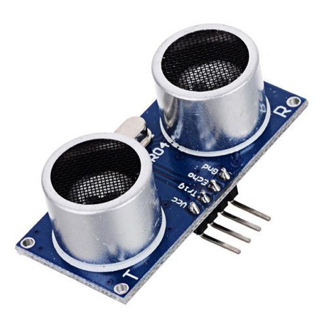 7

Fig. 2 Ultrasonic sensor 7

Fig. 3 Laser distance sensor 7

Fig. 4 System Diagram 9

Fig. 5Componets used in assembling the RSLK 14

Fig. 6 Tools used in assembling the RSLK 15

Fig. 7 Assembled RSLK 15

Fig. 8 Battery connections soldered as part of the attachment to the chassis 17

Fig. 9 Launch pad soldered together with long pins facing upward. 17

Fig. 10 Encoders soldered to motor drivers. 18

Fig. 11 Bump switches 18

Fig. 12 Motor board on chassis 18

Fig. 13 Ball caster 19

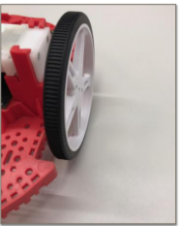 19

Fig. 14 Wheels attached 19

Fig. 15 Bump switches wiring 19

Fig. 16 Motor board wiring to launchpad 20

Fig. 17 Motor board wiring to launchpad 20

Fig. 18 Line sensor wiring guide 21

Fig. 19 Error messages received 22

Fig. 20 Switching off the antivirus 22

Assembled TI RSLK 23

Front view of IWR1443 Back view of IWR1443 26

The Block Diagram of the IWR1443 26

List of Tables

Table 1. Project Timeline and Delivery Plan 12

Table 2. Components of the ti rslk 15

Table 3. Bump switches connection guide 19

Table 4. Motorboard wiring guide 19

Table 5. Motor board wiring to ground and vreg 19

Table 6. Line Sensor Wiring Guide 20

Abstract

By the end of the project, summarize the project into short text and put here.

1. Introduction

In this project, we are going to develop an autonomous car using the TI-RSLK and the mmWave sensor (IWR1443BOOST). The autonomous car will be capable of different functions such as providing geographical information (such as range, velocity and angle) and proximity & position sensing.

## Backgound/Motivation

The TI Robotics Systems Learning Kit was created by TI as a low-cost robotics kit to provide students with a profound understanding of how electronic devices work. It was developed in conjunction with Dr. Jon Valvano, professor, electrical and computer engineering at The University of Texas at Austin. There are two different RSLK kits; the basic kit which teaches the foundations of an electric system and the advanced kit which contains all components found in basic kit, adding wireless communication to enable robot to solve its way through a maze by detecting lines and obstacles.

The mmWave sensor is an extremely valuable sensing technology for detection of objects and providing the range, velocity and angle of these objects. It is a contactless-technology which operates in the spectrum between 30GHz and 300GHz. Due to the technology’s use of small wavelengths it can provide sub-mm range accuracy and is able to penetrate certain materials such as plastic, drywall, clothing, and is impervious to environmental conditions such as rain, fog, dust and snow. The mmWave sensor has a clear advantage over other sensing technologies such as ultrasonic sensors and LIDAR. It has a long detection range, narrow and wide detection angle, good range resolution, and has good night operation performance.

The rover can be used in many situations such as in hostage situations and school shootings. In such situations, instead of law enforcement agencies to go in with guns blazing, it is better to access the situation at hand. The mmWave sensor on the rover can provide 3D point cloud information on the building where the situation occurred. It will also work better than a camera because of its long detection range, it’s narrow and wide detection angle, as well as it is good range resolution. From the 3D point cloud information provided by the mmWave sensor, the rover would be able to provide the best possible route for the officers to go through without being noticed by the “bad guys”.

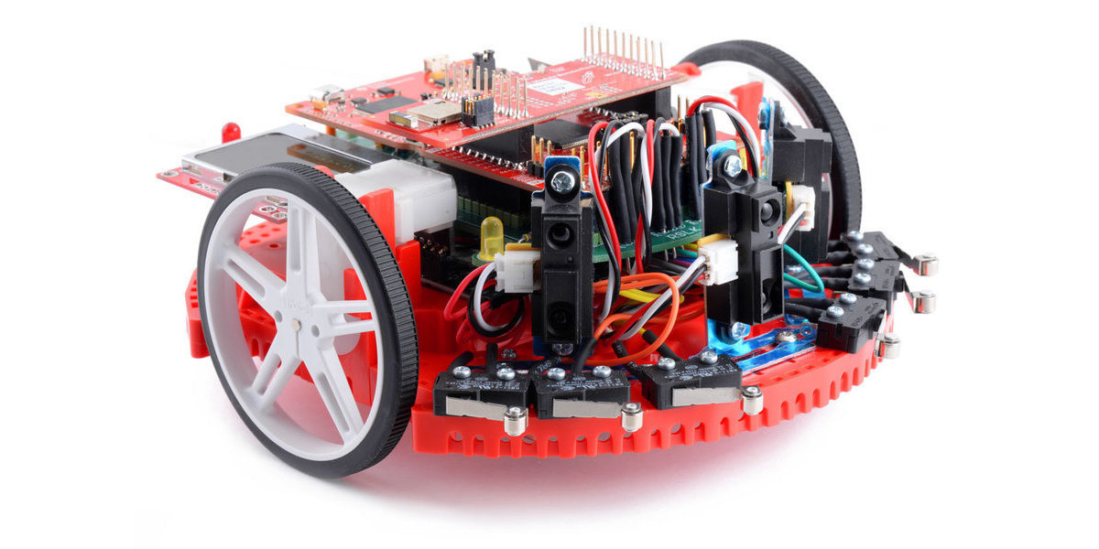

Fig. 1 Robotic system learning kit



Fig. 2 Ultrasonic sensor

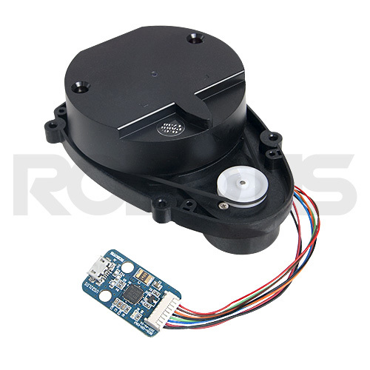

Fig. 3 Laser distance sensor

## Objective

The objective of the project is to design a rover that can acquire geographical acquisition such as the range, velocity, angle and 3D imaging of objects in an unknown area.

## Design Requirements

1. The device will be able to produce data using a point cloud information.
2. The device will be able to avoid obstacles while providing autonomous navigation
3. The payload of the car will be 15 to 20lbs
4. The device will detect object within the range 3cm to 10 m.
5. The device will have a resolution range of 10cm.

## Design Constraints

1. The tires might not be able to move well in certain terrains such as rocky areas.
2. Battery will have to be recharged after about 4 hours of use
3. The device would only work in mild weather conditions.

## Design Method (Approach)

Design methods refer to methods to explore possibilities and constraints by applying critical thinking through qualitative and quantitative research methods to develop solutions for your purposes.

Shortly, design methods are basic process to implement the project, for example, “The first step is to … The second step is to … …”.

## Standards

List in this section all (industry) standards the project complied with.

1. Project Description

In this section you are going to add more details of 'what' and answer the question 'how'.

## System Description

An autonomous car is controlled by a TI microcontroller MSP432 power by a 12-volt battery with a voltage regulator controlling the voltage input to the microcontrollers. The battery powers the Dc motor and sends the DC signal to a PWM input on the microcontroller. An IWR 1443 Boost mmWave Rader is connected to the microcontroller to server as a senor to the car. Also, an ODRIOD XU4Q is connected to the output signal of the microcontroller to control, access and save the data acquire from the sensors.

## System Diagram

Draw a system diagram here. The diagram should include every components and show there relationships. For complex system you can have multiple system diagrams, for example, the vehicle mechanical system diagram and electrical system diagram. Or if you have several subsystems, you can also draw diagrams for each of them.

Please make sure you marked the name/function of each component on the diagram, for example, 'motor' or 'wireless receiver'.

You should also put descriptions of every major component here.

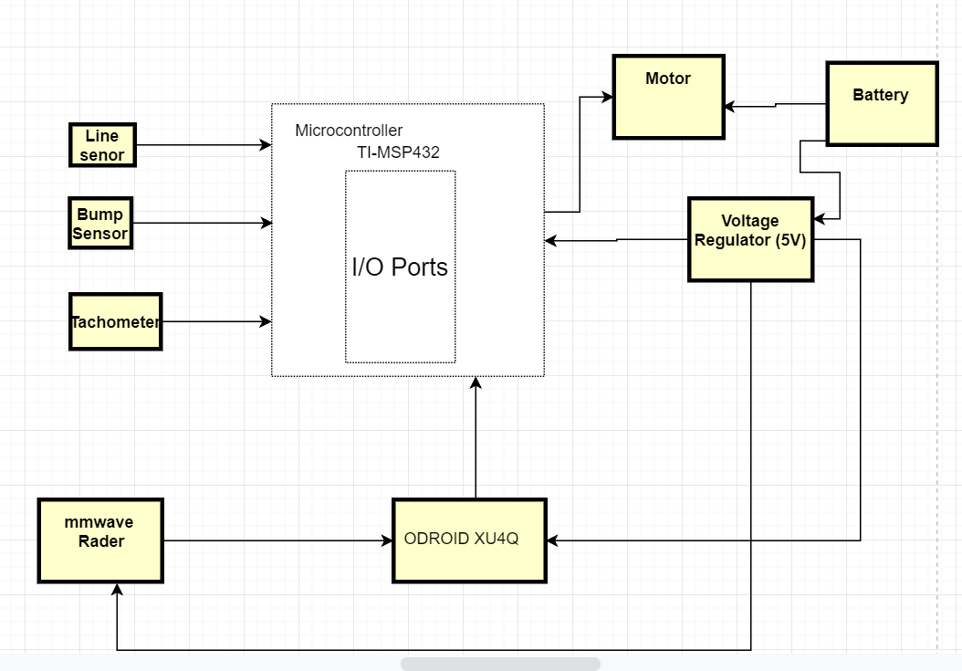

Fig. 4 System Diagram

## System Functions

Here you need to clearly define every function and every state of the system. Make you’re your state graph is complete. For example:

"

1. When the caller press a button, first the message will show on the display of the device with the caller, also the message will be coded together with its ID and send to the callee.
2. …

"

1. Implementation Plan

## Tasks

* Task 1. RLSK Assembly
  + Subtask 1: Soldering, Assembling and Wiring of TI RSLK Kit
  + Subtask 2: Writing and Modifying the Code for Bumps Sensors
  + Subtask 3: Writing and Modifying of the Code for Line Follow Sensor
* Task 2. Design of the computer system
  + Subtask 1: Setting up Ubuntu on the ODRIOD XU4Q
  + Subtask 2: Design of a power adapter for mmWave
  + Subtask 3: Implementing the mmWave interface with the microcomputer
* Task 3. Implementation and development of the mmWave sensor (IWR 1443 Boost)
  + Subtask 1: Mounting the mmWave to RSLK board
  + Subtask 2: Design and print a 3D part to help mount the mmWave
* Task 4. Acquisition of the point cloud data from the radar with the microcomputer.
  + Subtask 1: Launch the TI mmWave_rospkg node to start the mmWave EVM
  + Subtask 2: Visualize the Radar point cloud using RVI
* Task 5. Stitching Algorithm.
  + Subtask 1: 3D stitching of point cloud data
  + Subtask 2: Reflective object stitching
* Task 6. Detecting and calculating the distance of an object behind the glass wall.
* Task 7. Using the Tachometer to calculate the speed of the rover.
* Task 8. System Finalization, testing and refinement.

## Team Organization

### Responsibility of Aduralere Sulaiman

### Responsibility of Favour Dada.

Task 1, Subtask 2.2, …

### Responsibility of Jesudara Omidokun

## Timeline/Milestones/Delivery Plan

1. Project Timeline and Delivery Plan

|  |  |  |  |
| --- | --- | --- | --- |
| Time | Jesudara | Aduralere | Favour |
| Week 1 | Task 1, Sub 1a.  Soldering Components of RSLK task | Task 1, Subtask 2.  Write the code for the bump Sensors. | Task 1, Subtask 3.  Write. the code for the line Sensors |
| Week 2 | Task 1  1.2 Wiring Components of RSLK | Task 1  1.2 Write the code for the bump Sensors | Task 1  1.3 Write the code for the line Sensors. |
| Week 3 | Task 1  1.3 Assembling of RSLK component | Task 1  1.2 Assembling of RSLK | Task 1  1.3 Write the code for the line  Sensor |
| Week 4 | Task 1  1.3 Assembling of RSLK component | Task 1  1.2 Assembling of RSLK, compiling code, Uploading | Task 1  1.1 Assembling of RSLK. Compiling codes, Uploading codes |
| Week 5-7 | Task 3  3.1Mounting technic  3.2 3D design and printing | Task 2  2.3 Implementing the mmWwave interface with the microcomputer | Task 2  2.1 Design Power supply for ODROID Using Buck converter  2.2 Setting up Ubuntu on ODROID XU4Q |
| Week 7-11 | Task 4  Acquisition of the point cloud data from the radar with the microcomputer | Task 4  Acquisition of the point cloud data from the radar with the microcomputer | Task 5  5.1 4K FFT stitching of reflective object  5.2 Stitching 3D point cloud data |
| Week 11-13 | Task 4  Acquisition of the point cloud data from the radar with the microcomputer | Task 4  Acquisition of the point cloud data from the radar with the microcomputer | Task 5  5.2 Stitching the 3D point Cloud data. |
| Week 14-17 | Task 7  Using the Tachometer to calculate the speed | Task 6  Detecting and calculating the distance of an object behind the glass wall. | Task 6  Detecting and calculating the distance of an object behind the glass wall. |
| Week 18-20 | Task 8  System Finalization, testing and refinement. | Task 8  System Finalization, testing and refinement | Task 8  System Finalization, testing and refinement |
| Week 21- 22 | . |  |  |

1. Implementation

## Implementation of Task 1.

### Implementation of Subtask 1.1

This involves the use of different tools, wires and supplies to assemble the TI-RSLK. After the RSLK parts were assembled, the final assembly looked similar to the picture in Fig. 7. The tasks for the TI-RSLK was divided into four main sections

* **Soldering**
* **Assembly**
* **Software**
* **Wiring**

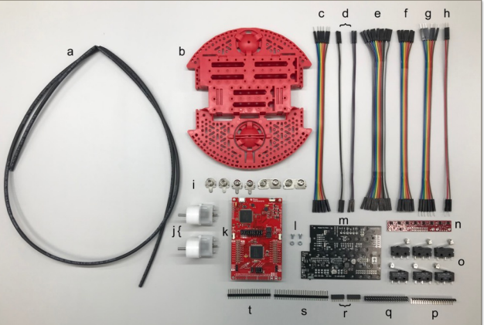

Fig. 5Componets used in assembling the RSLK

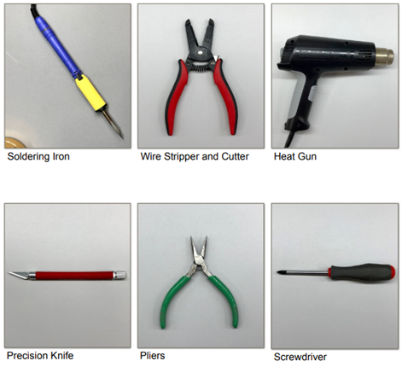

Fig. 6 Tools used in assembling the RSLK

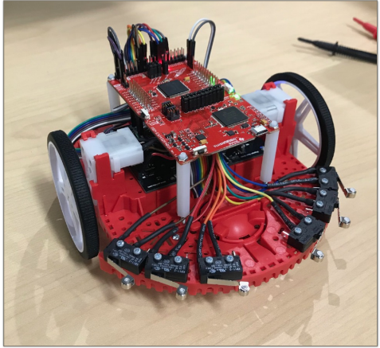

Fig. 7 Assembled RSLK

1. Components of the ti rslk

|  |  |  |
| --- | --- | --- |
|  | Description |  |
| A | Heat Shrink Tube | 1 |
| B | Chassis | 1 |
| C | 6 Female to Male Wires | 1 |
| D | 2 Female to Male Wires | 4 |
| E | 11 Female to Female Wires | 1 |
| F | 6 Female to Female Wires | 1 |
| G | 6 Male to Male Wires | 1 |
| H | 2 Male to Male Wires | 1 |
| I | Battery Terminals | 1 |
| J | Motor | 2 |
| K | TI Launchpad kit | 1 |
| L | Motor Board Screw | 1 |
| M | Motor Board | 1 |
| N | Line Follower Sensor | 1 |
| O | Bump Switch | 6 |
| P | 90 Bent Header | 1 |
| Q | 2x20 Header | 1 |
| R | 1x6 Header | 1 |
| S | 1x25 Header | 1 |
| T | 1x20 Header | 1 |
| U | Motor Encoders | 2 |
| V | Bump switch wire spade connector | 12 |

* Soldering

A precision knife is used to cut the VPU-VREG, VCCMD-VREG, and SLP L-R traces. A deep solid cut is then made through the small line connection between the square pads. Two 1x6 female socket headers are connected to the yellow connections before connected to the 1x2 headers and then to the ELA and ELB connections. The ELA and ELB connections need to be bent to a 45-degree angle after soldering. A 1x2 header cut is made on the VPU connection. A 1x3 header is made and so is a 1x6 header cut to the left and right motor driver connections. 1x3 and 1x2 header cuts are made to the VREG terminals. The 1x8, 1x3 and 1x2 header cuts are soldered to the GND terminals. The four battery connections were soldered as part of the attachment to the chassis and the motor board was secured with two support screws. Pliers are then used to bend out the ELA and ELB & ERA and ERB connections so the connections can be attached by wires to the Launchpad.

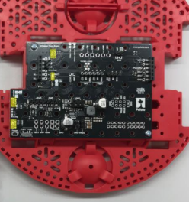

Fig. 8 Battery connections soldered as part of the attachment to the chassis

Launchpad: The 2x19 header is then soldered on the J5 pinout at the bottom of the launchpad with the long pins facing upward as seen in Fig. 9. The prepared encoders are then soldered on the motors. The bump switches; one male and one female wire each is soldered to each bump sensor. This is done for the 6 bump sensors as seen in Fig. 10

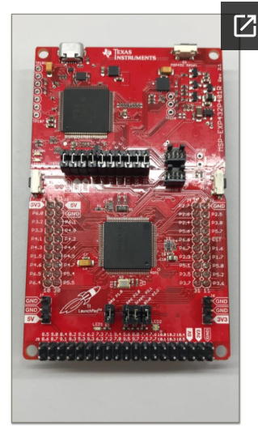

Fig. 9 Launch pad soldered together with long pins facing upward.

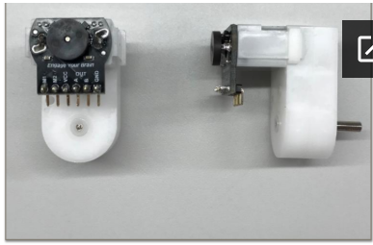

Fig. 10 Encoders soldered to motor drivers.

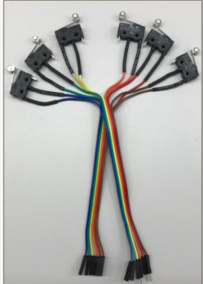

Fig. 11 Bump switches

* Assembly

The motors are attached to the motor board on the chassis.

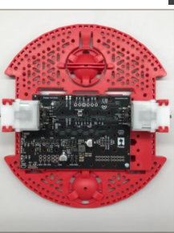

Fig. 12 Motor board on chassis

The ball caster is then attached to the chassis before the wheels are attached.

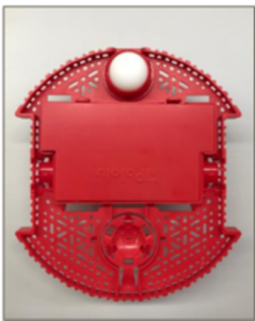

Fig. 13 Ball caster



Fig. 14 Wheels attached

* Wiring

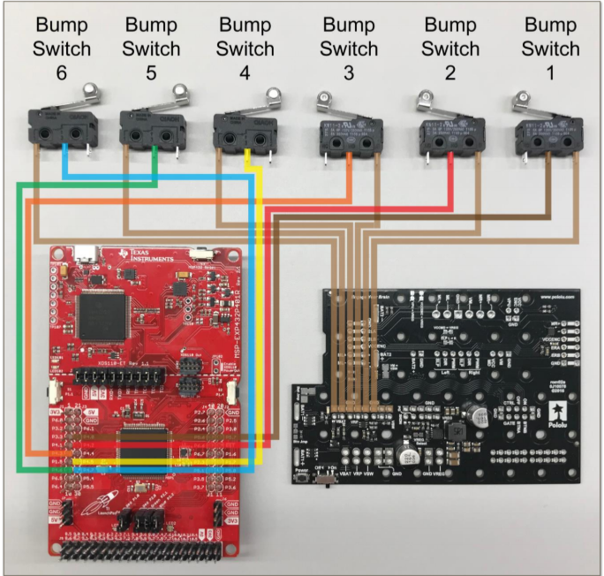

Fig. 15 Bump switches wiring

1. Bump switches connection guide

|  |  |  |  |  |  |
| --- | --- | --- | --- | --- | --- |
|  | Bump 1 | Bump 2 | Bump 3 | Bump 5 | Bump 6 |
| LaunchPad | P 4.0 | P.4.2 | P.4.5 | P.4.6 | P 4.7 |

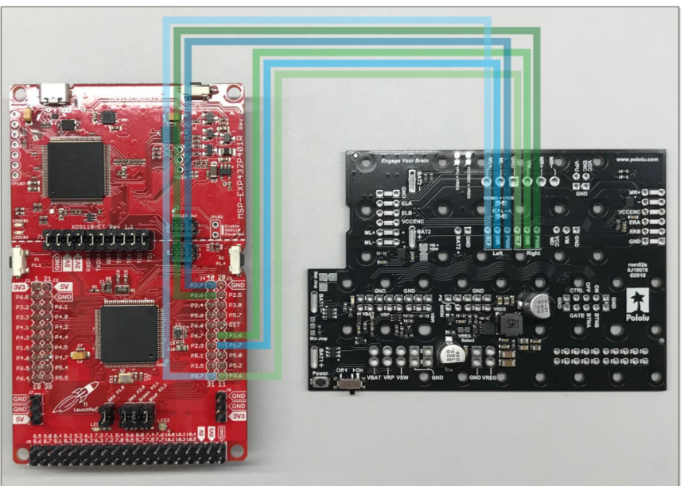

Fig. 16 Motor board wiring to launchpad

1. Motorboard wiring guide

|  |  |  |  |  |  |  |
| --- | --- | --- | --- | --- | --- | --- |
| Motor Board | Left SLP | Left DIR | Left PWM | Right SLP | Right DIR | Right PWM |
| Launchpad | P3.7 | P1.7 | P2.7 | P3.6 | P1.6 | P2.6 |

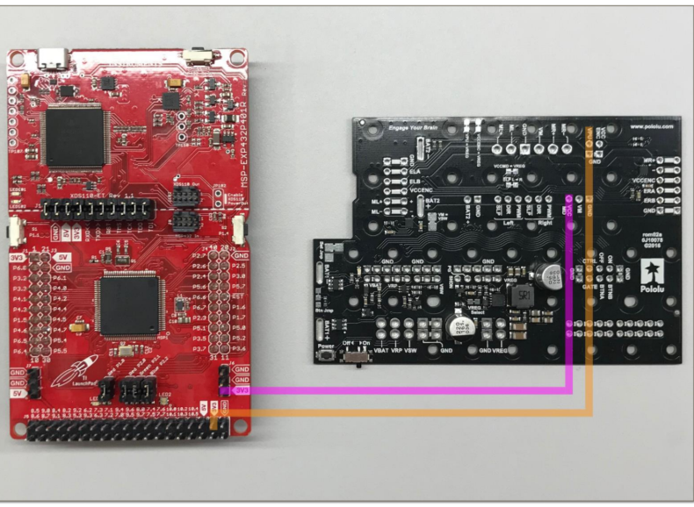

Fig. 17 Motor board wiring to launchpad

1. Motor board wiring to ground and vreg

|  |  |  |
| --- | --- | --- |
| Motor Board | VREG | GND |
| Launchpad | 5V | GND |

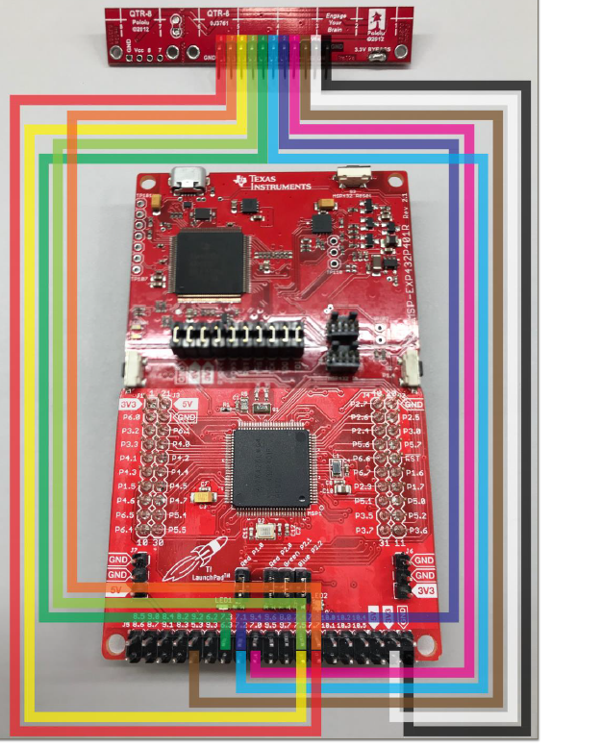

Fig. 18 Line sensor wiring guide

1. Line Sensor Wiring Guide

|  |  |  |  |  |  |  |  |  |  |  |  |
| --- | --- | --- | --- | --- | --- | --- | --- | --- | --- | --- | --- |
| Line Sensor | 8 | 7 | 6 | 5 | 4 | 3 | 2 | 1 | LED ON | VCC | GND |
| Launchpad | P7.7 | P7.6 | P7.5 | P7.4 | P7.3 | P7.2 | P7.1 | P7.0 | P5.3 | 3V3 | GND |

* Software

The steps to get the software working were;

1. Install CCS (Code Composer Studios)
2. Import the TI Drivers
3. Download RSLK Energia Library

* Troubleshooting
* Soldering:

The first issue encountered when soldering was having to solder the connectors upside down as this affected the wiring because the female connector wire removed due to the fact that the pins have different diameter from top to bottom.

The solution to this issue was to de-solder the connectors and then re-solder.

Another issue that was encountered when soldering was with the encoders. The encoder connector pins are flexible which made to fragile. During the attachment of the motor board to the motor, an encoder pin broke causing the motor to stop working.

The solution to this issue was to de-solder the encoder and find a less fragile pin and connector to use.

The motor also had a similar issue, but the only solution was to buy another motor.

* Assembly:

The main issue when assembling the parts was from the chassis motor clips. The chassis motor clips from the TI RSLK kit didn’t sit well on the chassis.

The solution to this issue was to break part of the motor clips in order to fit the motors. The motors where then slid into the motor clips without over-stressing the clips.

* Software:

One of the challenges was installing CCStudio on the computer. Different errors occurred during the installations.

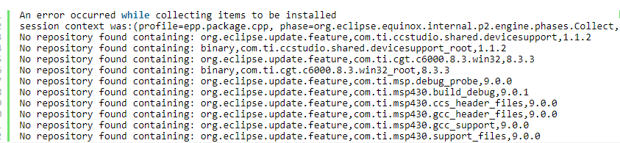

Fig. 19 Error messages received

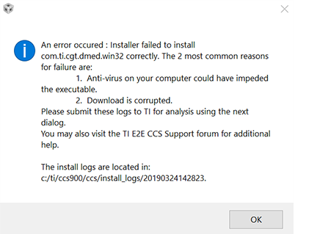

Fig. 20 Switching off the antivirus

This problem was then solved by turning off the antivirus on the computer before the installation. After the RSLK parts were assembled, the final assembly looked similar to the picture below;



Assembled TI RSLK

### Implementation of Subtask 1.2

### Implementation of Subtask 1.3

For this task the code for the line tracker was written and compiled. The RSLK has two line sensors one on the left and one for the right. The RSLK has two motors.

For the two sensors (left right)

1 1 explains that the RSLK is on the line

1 0 explains that the RSLK is off to the right

0 1 explains that the RSLK is off to the left

0 0 explains that the RSLK is lost

If the car detects black lines when there are white line the RSLK would only go through the white lines. The line sensor follows black lines only. The motor driver runs the finite state machine every 50 microseconds. The flow chart in FIG. summarizes the code. The source code for the line tracker can be found in Appendix section under source code 1.

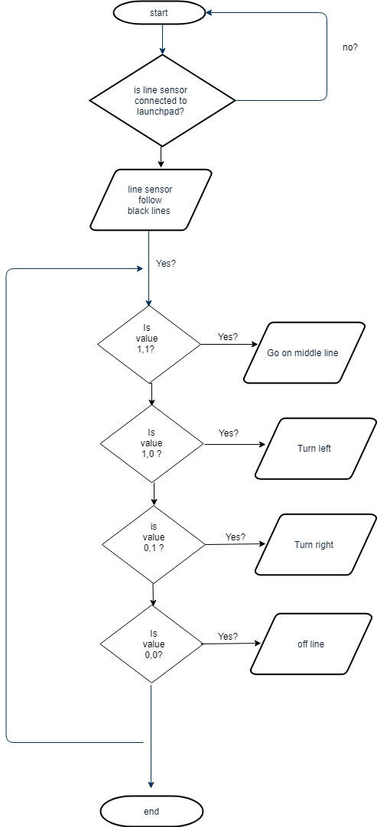

## Implementation of Task 2

### Implementation of Task Subtask 2.1

For this task the work was to use a battery cone LM256 has a transformer and the steps are from 35 to 225 volts and has a variable resistor used to regulate the voltage. The multimeter was used to regulate the voltage of 5v and also a maximum current of 2.5A.

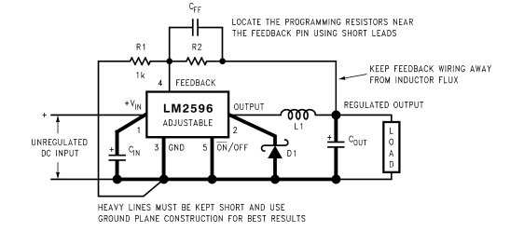

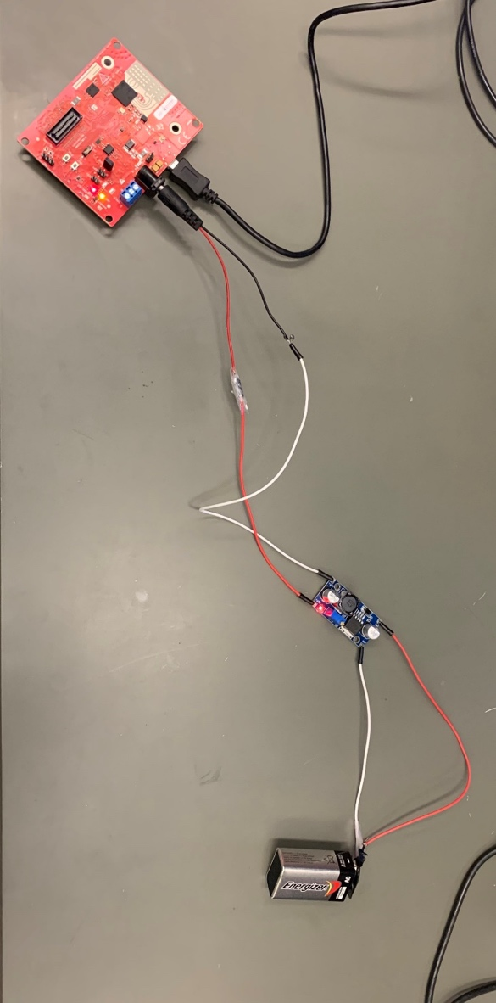

### Implementation of Task Subtask 2.2

For this task the installation of Ubuntu on the ODRIOD XU4Q was done. Firstly to install Ubuntu, download the Ubuntu

## Implementation of Task 2

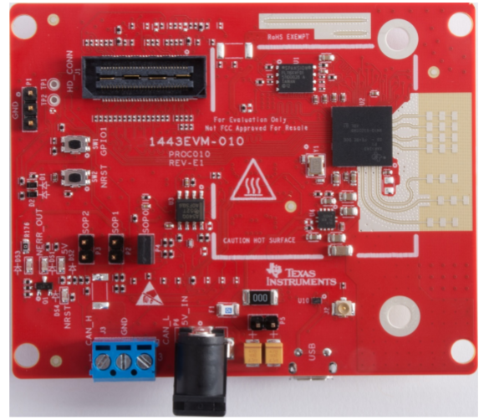

The IWR1443 BoosterPack™ is an easy-to-use evaluation board for the single-chip IWR1443 mmWave sensing device from TI, with direct connectivity to the TI MCU LaunchPad™ ecosystem. The evaluation board contains everything needed to start developing on a low-power ARM®-R4F controller. The evaluation board includes onboard emulation for programming and debugging, onboard buttons, and LEDs, for quick integration of a simple user interface. The standard 20-pin BoosterPack headers make the evaluation board compatible with a wide variety of TI MCU LaunchPads and enables easy prototyping.

The Key features of the mmWave are;

1. 40-pin Launchpad standard that leverages the Launchpad ecosystem
2. Backchannel UART through USB to PC, for logging purposes
3. Onboard antenna
4. One button and two LEDs, for user interaction • 5-V power jack, to power the board
5. XDS110-based JTAG emulation with serial port, for onboard QSPI flash programming.

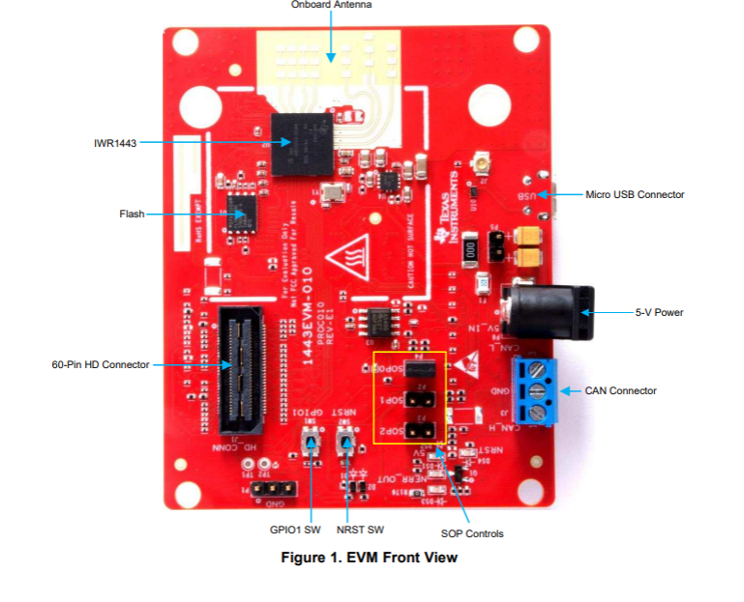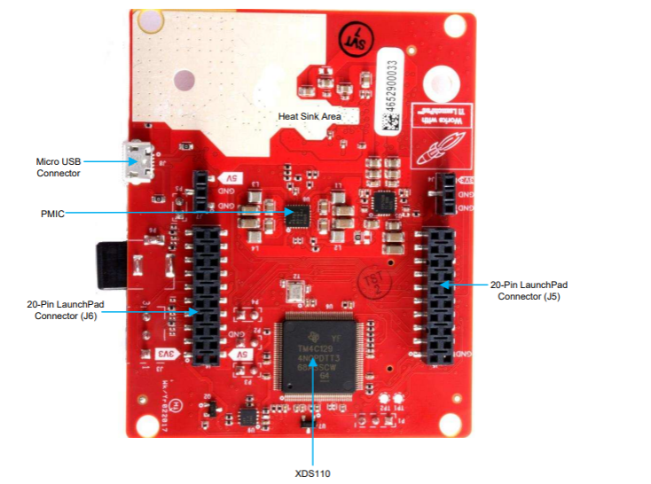

Front view of IWR1443 Back view of IWR1443

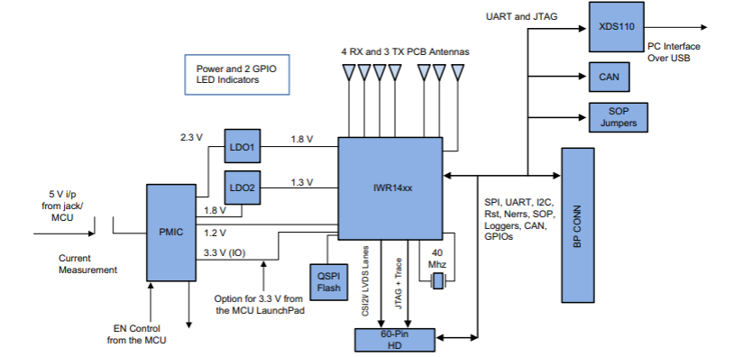

The Block Diagram of the IWR1443

* Regulatory Information

The IWR1443 evaluation module (IWR1443BOOST) is in compliance with Directive 2014/53/EU. The compliance has been verified in the operating bands 76 – 77 GHz and 77 – 81 GHz. Should the user choose to configure the EVM to operate outside the test conditions, it should be operated inside a protected or controlled environment, such as a shielded chamber. This evaluation board is intended only for development and is not for use in a product or part of an end product. Developers and integrators that incorporate the chipset in any end products are responsible for obtaining applicable regulatory approvals for such a product. The European RF exposure radiation limit is fulfilled if a minimum distance of 5 cm between the users’ body and the radio transmitter is respected.

To generate a point cloud from mmWave with a Robotic Operating System, the following requirements are needed;

1. 5VDC power supply (center positive barrel jack, 2.5A)
2. Ubuntu 16.04 LTS operating system
3. Robot Operating System (ROS)
4. ti_mmwave_rospkg source code
5. mmWave SDK software
6. UniFlash
7. Host PC (laptop or desktop)
8. TI mmWave 1443 ES3.0 EVM
9. USB to microUSB cable

**Why Robotic Operating System?**

The Robot Operating System (ROS) is a flexible framework for writing robot software. It is a collection of tools, libraries, and conventions that aim to simplify the task of creating complex and robust robot behavior across a wide variety of robotic platforms. mmWave FMCW Radar chirp profile through command line interface (CLI) on a UART port, Do 1D, 2D, CFAR, Azimuth and Elevation processing and stream out intensity, relative radial velocity and three spatial coordinates (x,y,z) of the detected objects in real-time. Because the ROS framework and libraries support point cloud data, ROS is useful for developing and prototyping with the mmWave EVMs for robotics applications

**Installing ROS**

The ROS kinetic Kame was selected among the two distribution that is commonly used now. The prerequisites for install ROS kinetic kame is install bootstrap dependencies, installing ROSDEP. The Installing Building the catkin Packages, Create a catkin workspace , Set up your keys, Install Debian package that contains( ROS, rqt, rviz, robot-generic libraries, 2D/3D simulators, navigation and 2D/3D perception and Environment setup under the ROS Workspace note install the rosbuild Not catkin.

Using the ti_mmwave_rospkg ROS driver

Install the ROS ‘serial’ package:

Use GIT to download (clone) the ROS serial driver into your /src directory: $ cd /src $ git clone <https://github.com/wjwwood/serial.git>.

More documentation on this library can be found at: http://wjwwood.io/serial/ TI mmWave ROS Driver Setup Guide Version 1.5 6 3. Download the TI mmWave ROS Driver (ti_mmwave_rospkg) and copy it to your /src.

After opening the ti_mmave_rospkg_.zip file, see the ti_mmwave_rospkg. Open a new file browser and navigate to your /src directory. Copy the ti_mmwave_rospkg folder to the /src directory.

Build your project: In the Terminal/shell, go to your directory and build the driver: $ cd $ catkin_make.

Flash the mmWave using the UniFlash

Launch the TI mmWave ROS node and Rviz visualizer by running $ rosrun rviz rviz

**Troubleshooting**

The main issue faced was when flashing the IWR1443 device with Uniflash.

Solution:

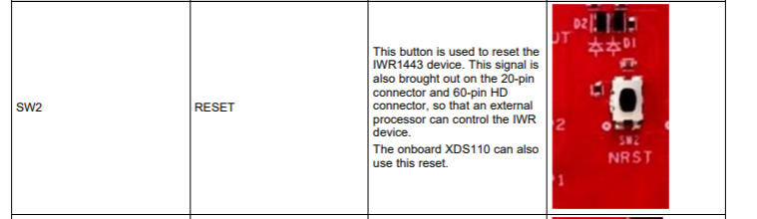

…

## Implementation of Task 5

### Implementation of Task Subtask 5.1

Fig below explains that for a stitching of a 3D point cloud data the first step is to register a collection of point cloud data that was collected from a robotic operating system visualizer. The robotic operating system visualizer stores files as an .obj file. To stitch the 3d point cloud data collected, the .obj file is converted to a .pcd file. After the file is converted from .obj to .pcd the file would be loaded unto the Pcd visualizer app to stitch the 3D point cloud data. The code for converting the .obj file to .pcd can be found in the appendix section.

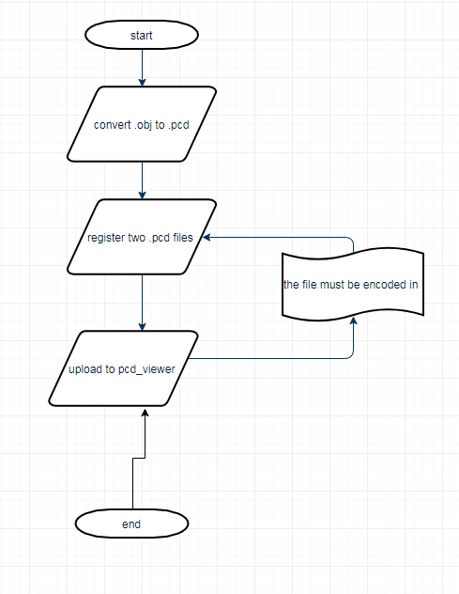

### Implementation of Task Subtask 5.2

For this task the stitching algorithm was implemented on the TI mmWave sensors IWR1443 EVM. The mmWave has a hardware accelerator engine that supports the FFT processing for a 1D FFT (range) calculation. The code enables a highly reflective object to be detected in front of the EVM. The stitching code implementation shows a 2 step FFT of 1024-pointFFT with windowing of fractional interpolation turned on. The 1024 iteration of 4-point FFT. Each step of the FFT processing is handled by a parameter set. The Data path has the chirp data processed in a ping pong manner having the Mx as the local memory of the hardware accelerator.

ADC_ping (M0) -> 1K FFT -> M2 -> 4 FFT -> M3 -> (EDMA) -> L3

ADC_ping (M1) -> 1K FFT -> M3 -> 4 FFT -> M32-> (EDMA) -> L3

The ADC output buffer is shared between M0 and M1, there is no need for EDMA transfer until the output data is ready for transfer to radar cube memory L3.

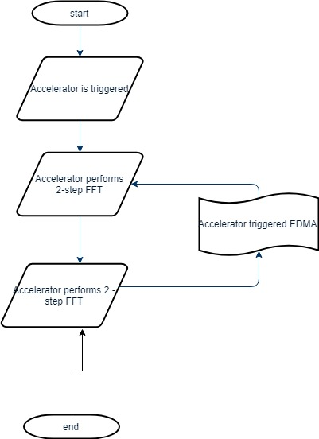

The usefulness of this task is to get the range profile of the highly reflective materials in the range distance. The first step in this process is to put the mmWave IWR1443 Boost EVM in flashing mode by connecting the jumpers on SOP0 and SOP2. Open the UniFlash tool downloaded on Ti.com/tool/uniflash to flash the prebuilt in binaries mmWave IWR1443 Boost EVM. Power cycle the mmWave and connect the mmWave with a USB to the computer being used, the mmWave has two virtual COM port as shown in the FIG below. In the new configuration section locate and select the IWR1443 Boost EVM. Click start to proceed. In the program tab browse and locate the Radar SS and MSS images for the 4k FFT prebuilt in binaries as seen in the FIG below. In the settings and utilities port fill in the $COM_{UART}$ noted earlier as shown in the FIG below to flash the previous binaries. Return to the program tab and power cycle the device and click on load images of the prebuilt in binaries specified earlier. When the flash procedure is complete the UniFlash console should indicate [SUCCESS] Program Load completed successfully. Power off the board and remove the jumper from only SOP2, removing it puts the board in functional mode. The

1. Conclusion (Discussion and Future Plans)

By the end of the project, conclude the project and your learning experience.

Acknowledgment

If you get help or support from someone else (besides the team member and the advisor) and want to show your appreciation, put here (**do not include the advisor**).

Appendix

You can put reference info here, including: i) specs of components used in the system, ii) source code (must be here but not in the body text), iii) CAD figures, etc.

1. Component Specs
2. Specs of Arduino Due

...

1. Specs of Raspberry Pi

…

1. Source Code.
2. Source Code of Line sensor
3. Source Code of Bump Switches
4. Source code for Converting from .obj file to .pcd file
5. Source Code of 4k ftt stitching Algorithm
6. Source code for 3d point cloud stitching

REFERENCES

[1] D. Vantrease, R. Schreiber, M. Monchiero, M. McLaren, N. P. Jouppi, M. Fiorentino*, et al.*, "Corona: System Implications of Emerging Nanophotonic Technology," in *Computer Architecture, 2008. ISCA '08. 35th International Symposium on*, 2008, pp. 153-164.

[2] X. Zhang and A. Louri, "A multilayer nanophotonic interconnection network for on-chip many-core communications," in *Design Automation Conference (DAC), 2010 47th ACM/IEEE*, 2010, pp. 156-161.

[3] C. Batten, A. Joshi, J. Orcutt, A. Khilo, B. Moss, C. Holzwarth*, et al.*, "Building manycore processor-to-DRAM networks with monolithic silicon photonics," in *High Performance Interconnects, 2008. HOTI '08. 16th IEEE Symposium on*, 2008, pp. 21-30.

[4] Y. Pan, P. Kumar, J. Kim, G. Memik, Y. Zhang, and A. Choudhary, "Firefly: illuminating future network-on-chip with nanophotonics," in *IEEE/ACM Intl. Symp. on Computer Architecture (ISCA)*, 2009, pp. 429-440.

[5] N. Kirman, M. Kirman, R. K. Dokania, J. F. Martinez, A. B. Apsel, M. A. Watkins*, et al.*, "Leveraging Optical Technology in Future Bus-based Chip Multiprocessors," in *Microarchitecture, 2006. MICRO-39. 39th Annual IEEE/ACM International Symposium on*, 2006, pp. 492-503.

[6] J. M. Cianchetti, C. J. Kerekes, and H. D. Albonesi, "Phastlane: a rapid transit optical routing network," in *Proceeding of: 36th International Symposium on Computer Architecture (ISCA)*, 2009, pp. 441-450.

[7] A. Shacham, K. Bergman, and L. P. Carloni, "Photonic Networks-on-Chip for Future Generations of Chip Multiprocessors," *Computers, IEEE Transactions on,* vol. 57, pp. 1246-1260, 2008.

[8] A. Shacham, K. Bergman, and L. P. Carloni, "On the Design of a Photonic Network-on-Chip," in *First International Symposium on Networks-on-Chip, 2007. NOCS 2007*, 2007, pp. 53-64.

[9] M. Kwai Hung, Y. Yaoyao, W. Xiaowen, Z. Wei, L. Weichen, and X. Jiang, "A Hierarchical Hybrid Optical-Electronic Network-on-Chip," in *VLSI (ISVLSI), 2010 IEEE Computer Society Annual Symposium on*, 2010, pp. 327-332.

[10] D. Ding and D. Z. Pan, "OIL: a nano-photonics optical interconnect library for a new photonic networks-on-chip architecture," presented at the Proceedings of the 11th international workshop on System level interconnect prediction, San Francisco, CA, USA, 2009.

[11] A. Joshi, C. Batten, K. Yong-Jin, S. Beamer, I. Shamim, K. Asanovic*, et al.*, "Silicon-photonic clos networks for global on-chip communication," in *Networks-on-Chip, 2009. NoCS 2009. 3rd ACM/IEEE International Symposium on*, 2009, pp. 124-133.

[12] D. Vantrease, R. Schreiber, M. Monchiero, M. McLaren, N. P. Jouppi, M. Fiorentino*, et al.*, "Corona: system implications of emerging nanophotonic technology," in *Proc. 35th IEEE/ACM Int'l Symp. Computer Architecture (ISCA)*, 2008, pp. 153-164.

[13] L. Zhang, E. Regentova, and X. Tan, "A 2D-Torus Based Packet Switching Optical Network-on-Chip Architecture," presented at the *IEEE International Symposium on Photonics and Optoelectronics* (SOPO 2011), Wuhan, China, 2011.

[14] L. Zhang, E. E. Regentova, and X. Tan, "Packet switching optical network-on-chip architectures," *Comput. Electr. Eng.,* vol. 39, pp. 697-714, 2013.

[15] G. Huaxi, X. Jiang, and W. Zheng, "A novel optical mesh network-on-chip for gigascale systems-on-chip," in *Circuits and Systems, 2008. APCCAS 2008. IEEE Asia Pacific Conference on*, 2008, pp. 1728-1731.

[16] G. Huaxi, X. Jiang, and Z. Wei, "A low-power fat tree-based optical Network-On-Chip for multiprocessor system-on-chip," in *Design, Automation & Test in Europe Conference & Exhibition, 2009. DATE '09.*, 2009, pp. 3-8.

[17] Y. Yaoyao, X. Jiang, H. Baihan, W. Xiaowen, Z. Wei, W. Xuan*, et al.*, "3-D Mesh-Based Optical Network-on-Chip for Multiprocessor System-on-Chip," *Computer-Aided Design of Integrated Circuits and Systems, IEEE Transactions on,* vol. 32, pp. 584-596, 2013.

[18] A. Shacham, K. Bergman, and L. P. Carloni, "Photonic networks-on-chip for future generations of chip multiprocessors," *IEEE Trans. Computers,* vol. 57, pp. 1246-1260, 2008.

[19] A. W. Poon, F. X. Xu, and X. Luo, "Cascaded active silicon microresonator array cross-connect circuits for WDM networks-on-chip," in *Proc. SPIE*, 2008, p. 689812.

[20] M. Lipson, "Compact Electro-Optic Modulators on a Silicon Chip," *IEEE Journal of Selected Topics in Quantum Electronics,* vol. 12, pp. 1520-1526, 2006.

[21] M. Lipson, "Guiding, modulating, and emitting light on Silicon-challenges and opportunities," *Lightwave Technology, Journal of,* vol. 23, pp. 4222-4238, 2005.

[22] T. Xianfang, Y. Mei, Z. Lei, J. Yingtao, and Y. Jianyi, "Wavelength-routed optical networks-on-chip built with comb switches," in *Photonics Conference (IPC), 2013 IEEE*, 2013, pp. 46-47.